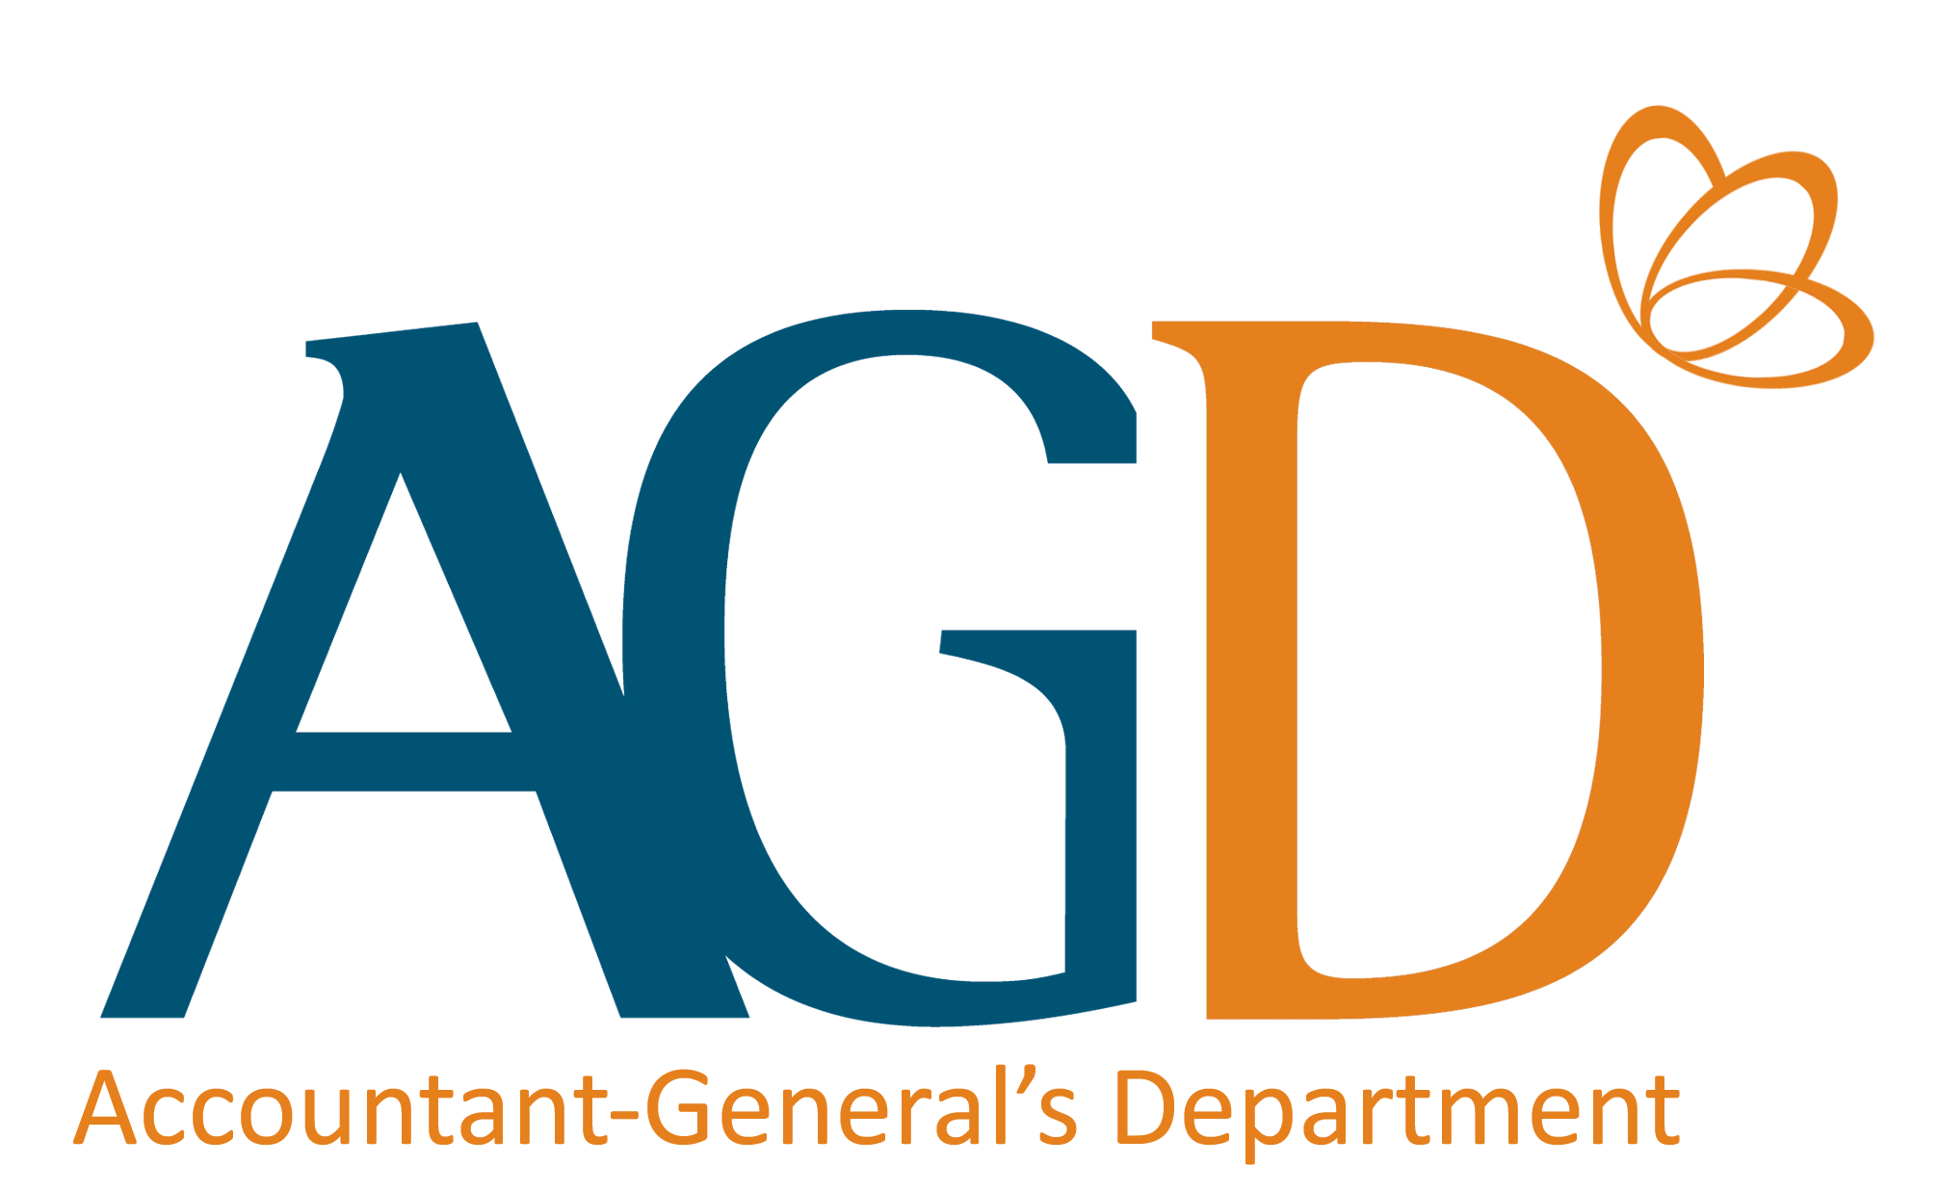
No correction tape/fluid should be used on this form. Any cancellations made must be endorsed by the same authorised signatories signing this form AND bank.

DIRECT CREDIT AUTHORISATION FORM

(Only Originals are Accepted)

Please complete Part II, obtain your bank’s endorsement for Part III and mail the original form (fax copy not acceptable) to the Ministry/Department/Statutory Board that you are liaising with.

Please note:

If you are receiving payment as an individual, fill in your name as stated in your NRIC/FIN.

If you are receiving payment as a Singapore registered company/business/society, fill in your organisation’s name as registered with ACRA/UEN. You may check your registered name on www.uen.gov.sg.

Leave Part III blank if you are an ACRA-registered organisation/Singapore Citizen/Permanent Resident AND you hold a bank account with DBS/POSB/OCBC/UOB/Far Eastern Bank (FEB)/Citibank.

PART I - TO BE COMPLETED BY THE REQUESTING MINISTRY/DEPARTMENT/STATUTORY BOARD
Name of Ministry/Department/Statutory Board | Ministry of Culture, Community & Youth |  | Vendor ID
Contact Officer |  |  | Please tick one of the relevant boxes:
Contact Number |  |  | New vendor record
Fax Number | 6837 8961 |  | Update of existing vendor record

PART II – TO BE COMPLETED BY ENTITY RECEIVING PAYMENT FROM THE GOVERNMENT/STATUTORY BOARD

All fields are mandatory. Incomplete forms will not be processed.

To: ACCOUNTANT-GENERAL
*It is mandatory to provide the email address. Payment notification will be sent to this email address.
UEN No.
(for all UEN registered entities)
OR
NRIC / FIN
(for individuals)
OR
Others
(e.g. Foreign Passport No)
GST Registered | Yes / No
GST Registration No.

Address
Telephone Number
Fax Number
Email Address*

Name(s) of Bank Account Holder(s):

Bank No. |  |  |  |  | Branch No. |  |  |  | Bank Account No. to be Credited

Bank and Branch Name

- I/We hereby authorise the Government and Statutory Boards to credit payments due to me/us to the above account. Amounts so credited would constitute valid discharge of obligations due to me/us.
- This authorisation shall continue to be in force until I/we have notified you in writing.
- I/We hereby request and authorise the Government and Statutory Boards to obtain confirmation/verification of information relating to me/us and/or to my/our account(s) from/with the bank where the Account is maintained as stated in the form.
- In consideration of the Government and Statutory Boards acceding to my/our said request and in consideration of the Bank confirming/verifying such information pursuant to the said request, I/we irrevocably consent to and authorise the Bank, including any officer thereof, to disclose any information whatsoever relating to me/us and to the Account as is necessary for the sole purpose of account validation and agree that such authorisation shall survive any termination of the Account. I/We agree that this consent shall survive the termination of any of the Account with the Bank and may be relied on and enforced as fully and effectively by the Bank as if it is addressed to the Bank.
- I hereby consent to the release of my updated address by the Immigration and Checkpoints Authority (ICA) to the Accountant-General’s Department for the purpose of sending the Remittance Advice to me.

Authorised Signature(s) & Stamp as in Bank’s Record Date
PART III – TO BE COMPLETED BY BANK

To: ACCOUNTANT-GENERAL

We hereby certify that the signature(s) and other particulars as stated in Part II agree with that contained in our records.

Name & Signature of Authorised Bank Officer Date & Bank’s Official Stamp

