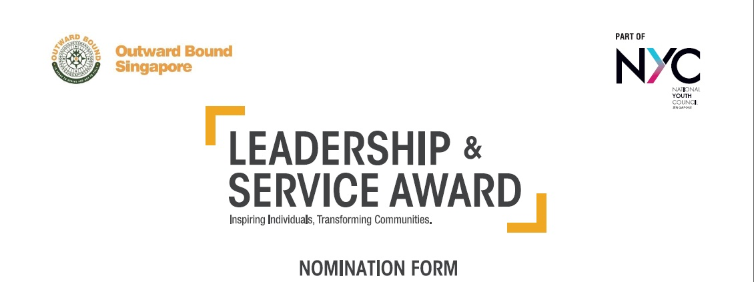

2020

The Leadership and Service Award (LSA) is open to youths with leadership potential and an active track record in community volunteerism. Award winners will be fully subsidised to attend the Outward Bound Singapore’s Classic 21-Day Challenge Programme. Shortlisted participants of the programme will undergo what many have termed as “an experience of a lifetime”, to hone their leadership capabilities and broaden their community perspectives. Graduates from the programme are expected to take up leadership roles in service projects for the community, both at the team and individual levels.

There are a total of three LSA award given out in 2020. Please select the appropriate course date that your nominees can attend. If you do not have the names of the nominees as of now, you can provide the estimated number of nominees by the closing dates. The nominees’ names can be submitted one month before the closing date for each round.

Organisation : ________________________________________________ Person-in-charge: ___________________________________

Contact Number : ____________________ (Office) ____________________ (Mobile) Email Address : ____________________________

PROGRAMME | COURSE DATE | SELECTION DATE | INTERVIEW DATE | PRE-COURSE BRIEF | SPONSORSHIP AWARD | REMARKS | CLOSING DATES FOR SUBMISSION OF NAMES
Leadership and Service Award (21-Day Classic Challenge) | 9 – 29 Mar 2020 | 18 Jan 2020 | 8 Feb 2020 | 22 Feb 2020 | 100% course fees of about $5,000 for the 21 day programme | Please nominate up to a maximum of 10 students | 13 Dec 2019
 | 6 – 26 Jul 2020 | 11 Apr 2020 | 2 May 2020 | 6 Jun 2020 |  |  | 28 Feb 2020
 | 30 Nov – 20 Dec 2020 | 19 Sep 2020 | 10 Oct 2020 | 7 Nov 2020 |  |  | 7 Aug 2020

Name of Nominee | NRIC | Faculty / Course of Study / Department / Unit | Contact Number | Contact Email | LSA Course Date Selected

The nominees are aware of the following: (please check the boxes below)
☐ Selection, interview, award ceremony and course dates.
☐ Requirements of the community service project component after the 21-Day Classic Challenge programme.

Kindly return the following to OBS by the respective closing dates:
- Nomination List (Email to OBS)
- Individual Registration Forms of Nominees (Individual registration through Form.SG)
- Relevant Supporting Documents (Submitted through Form.SG)

